**POS SRS DRAFT 1**

**By Ciara Jessica Villanueva, Carl Patterson, Yair Chaya**

### 1. Introduction

The sponsor for this project would like to create a Point of Sales system for retail stores and other consumer services.

### 2. Executive Summary

The client would like to create a smoother and more accessible system to conduct sales, in order to improve the experience of its users. The system will allow its users to:

* Purchase, return and exchange items using multiple payment methods
* Maintain records of all transactions
* Generate graphical reports for analysis
* Monitor inventory and place orders when it runs low

Some features of the system are:

* Placing transactions on hold: Users can place transactions on hold allowing them to process other transactions and resume when necessary.
* House accounts: Users can have house accounts with a balance that lets them pay for products at their convenience; unless the account is at its limit.
* Split payments: Users can choose to complete a transaction using multiple payment methods (ex, credit card and cash)

### 3. Purpose

The purpose of this document is to present a detailed description of the business software with the requirements offered to us in Exhibit A. It will explain the purpose and features of the software and what the software will do. This document is intended for users of the software.

#### 3.1 Document Conventions

This document was created based on the IEEE template for System Requirement Specification Documents.

#### 3.2 Intended Audience

* Users working in retail
* Managers and/or figures of authority documenting sales for records and/or teaching Users

#### 3.3 Product Scope

This software is a tool used in retail services, made for conducting the sales of products and storing data for future use. Users can process sale transactions and return transactions, both separately and simultaneously, split transactions for multiple payment methods, hold transactions and start new ones in the meantime, and create house charge accounts for buyers that function as tabs with a hard limit. Users can also update the inventory to include new stock and modify tax calculation via selecting a different tax categories. Users can cancel sales during the transaction and right before checkout. Users can also create a customer database where they can add new customers, search for customers via attributes, and select customers for new transactions.

### 4. Abbreviations and Definitions

1. **UPC** - Universal Product Code

2. **WIC** - Women, Infants, and Children Nutrition Program

3. **SNAP** - Supplemental Nutrition Assistance Program

4. **ACID Properties** -

**A** - Atomically (Everything happens at once or not at all

**C** - Consistency (Database is consistent - remains the same before and after)

**I** - Isolation (Transactions do not crossover, database is updated one transaction at a time)

**D** - Durability (The database remains even through system failure. There is redundancy)

5. **User** - The individual, with normal or administrator permissions that interact with the system

6. **Administrator -** User with elevated privileges that is allowed to perform tasks related to administration of the system.

7. **House Charge Account** - An optional account available to customers that allows them to purchase goods and pay for them at a later date.

8. **House Charge Limit** - The limit placed on a house charge account, managed by administrators.

### 5. Functional Requirements

**5.1 Typical User**

**5.1.1 User Login**

5.1.1.1 The system will require the user to log into the POS system in order to access regular user functionality. The user will not have access to additional administrative functionality.

5.1.1.2 The user can log into the system by scanning their employee ID card or by entering a username and password.

5.1.1.3 Once logged in, all activities done by the user during the session will be recorded into the system database. This includes all completed transactions, inventory changes, including item count changes and price changes, and customer database changes.

**5.1.2 Transactions**

5.1.2.1 The user shall be able to start a new transaction, either by scanning a new item after completing a previous transaction, or by clicking the ‘New Transaction’ button.

5.1.2.2 The user shall be able to delete a transaction before completion by clicking the ‘Delete’ button. Once deleted, all data relating to the transaction will be wiped, as if the transaction had never been started in the first place.

5.1.2.3 The user shall be able to suspend a transaction by clicking the ‘Hold’ button. This will create a new tab that will allow the user to start a new transaction to complete if necessary. The system can suspend a maximum of six sales at a time. If this threshold is reached, the user must either complete or delete a transaction in order to start a new one.

**5.1.2.4 Entering an Item**

5.1.2.4.1 The user shall be able to enter an item into a transaction by scanning its barcode.

5.1.2.4.2 The user shall be able to enter an item into a transaction by its UPC code.

5.1.2.4.3 The user shall be able to enter an item into a transaction by manually selecting it from the item inventory.

**5.1.2.5 Removing an Item**

5.1.2.5.1 The user shall be able to remove an item from a transaction during the sale by selecting the item and clicking ‘Remove’.

5.1.2.5.2 The user shall be able to remove an item from a transaction right before checkout by selecting the item and clicking ‘Remove’.

**5.1.2.6 Returning an Item**

5.1.2.6.1 The user shall be able to refund an item to a customer by scanning the sale’s receipt barcode and selecting the item that will be returned. Once selected, the payment will be refunded via the payment method used for that particular purchase.

5.1.2.6.2 If the sale was split using multiple payment methods, then the refunded payment will be sent to the first payment method used.

5.1.2.6.3 If the customer is also buying items, then the amount refunded will be subtracted from the total price of the new items. The customer will then pay the difference.

5.1.2.6.4 If the price of the refunded item exceeds the total price of the items to be bought, then the payment will instead be refunded via the first payment method of the previous sale, requiring the customer to pay the full amount of the new sale.

**5.1.2.7 Calculate Taxes**

5.1.2.7.1 The system allows automatic tax calculation if items are present in the item record.

5.1.2.7.2 The user shall be able to manually override the automatic calculation for a new tax category.

5.1.2.7.3 The user shall be able to select a new tax category and have the transactions taxes calculated from that.

**5.1.2.8 Payment**

5.1.2.8.1 The user shall be able to select one payment method for transactions. Acceptable payment methods include: Cash, Card (Credit and Debit), Mobile Banking, Check, Coupons, Gift Cards, WIC, and Food Stamps.

5.1.2.8.2 The user shall be able to split a transaction to allow multiple payment methods. Up to six different payment methods will be allowed.

5.1.2.8.3 If cash is a selected payment method, then the user shall be able to manually enter the cash tendered to calculate change.

5.1.2.8.4 If cash is a selected payment method, then the user shall be able to select exact change in lieu of rounded change.

**5.1.2.9 House Charge Account**

5.1.2.9.1 The system allows the creation of a house charge account, which functions as a tab. The account keeps track of the amount owed by a specific customer.

5.1.2.9.2 The house charge account has a maximum threshold that can be set by the administrator, both concurrently with multiple accounts, and separately. Once that threshold is reached, an alert will be sent to the account holder, and if the amount owed is not paid within a month of the alert, the account will be put on hold. Afterward, the holder will not be able to charge more to the account until the full amount is paid off.

5.1.2.9.3 If the customer pays more than what is owed to the account, the difference will be reflected as credit added to the account. Anything bought afterward will be deducted from the credit until it is gone.

**5.1.2.10 End of Transaction**

5.1.2.10.1 At the end of a transaction, the system will always print a receipt for the sale. This receipt will contain items bought, returned, taxes, and overall charge, along with a barcode that, when scanned, will allow a user to access the sale.

5.1.2.10.2 If cash is one of the payment methods selected, then the cash-drawer will automatically open if the cash tendered renders a change of a non-zero amount.

**5.1.2.11 Customer Database**

5.1.2.11.1 The user shall be able to manually select a customer from the database.

5.1.2.11.2 The user shall be able to add new customers to the database. When adding a new customer, the user will be prompted to fill out a profile for the customer, containing attributes that will allow users to search for the customer. These attributes are not mandatory; attributes left empty will be defined as NULL.

5.1.2.11.3 The user can search for customers via attributes attached to the customer’s profile.

**5.2 Administrator**

**5.2.1 Administrative Login**

5.2.1.1 The system will require the administrator to log into the POS system to use the additional administrator functionality in the system. Once logged in, the administrator will have access to the administrator functionality in addition to the regular user functionality.

5.2.1.2 The administrator shall be able to log into the system by scanning their employee ID or by entering their regular username and password.

**5.2.2 Dashboard**

5.2.2.1 Once the administrator logs in, their interface will have more options options added to their home screen, allowing them to generate reports and manage house charge accounts.

**5.2.3 Managing House Charge Accounts**

5.2.3.1 The administrator shall be able to set the maximum available amount for multiple house charge accounts.

5.2.3.2 The administrator shall be able to set the maximum available amount for separate house charge accounts.

5.2.3.3 The administrator shall be able to increase and decrease the maximum available amount for all house charge accounts.

**5.2.4 Generating Reports**

5.2.4.1 The administrator shall be able to generate reports for a single user for a certain time period specified by the administrator. This report shall contain all activity from that user during that time, including transactions, price change requests, changes to inventory, and the overall amount of time logged into the system.

5.2.4.2 The administrator shall be able to generate reports for item sales and returns for a certain time period specified by the administrator. These reports shall contain the frequencies at which the item was bought and returned, and the overall profit compared to the price of the item’s stock.

5.2.4.3 The administrator shall be able to generate reports for changes to inventory for a certain period specified by the administrator. These reports shall contain changes in price and item counts, all grouped by the item they were applied to and displayed in chronological order.

### 6. Non-Functional Requirements

6.1 The system shall have multiple terminals connected to one central local server.

6.2 Transactions will happen in parallel.

6.3 The system will follow ACID properties.

6.4 The system will create and store a backup periodically, so there will be minimal loss in case of a crash or some other similar event.

### 7. Software Qualities

* Fast
* Scalable
* Usable
* Replicable
* Stabie
* Modular

### 8. Use Case Glossary

|  |  |  |
| --- | --- | --- |
| **Use Case** | **Description** | **Actors** |
| Sign-in | The actor uses this interface, entering their username and password to gain access to the system | User, Administrator |
| Start New Transaction | This is initiated by clicking on new sale, scanning an item's barcode or by entering an item manually | User, Administrator |
| Hold Transaction | Transactions can be placed on hold if necessary | User, Administrator |
| Refund Item | Items can be refunded both in their own transaction or during a new transaction | User, Administrator |
| Resume Transaction | Resume a transaction placed on hold | User, Administrator |
| Complete Transaction | A transaction is completed when the customer pays for their items (using either of the supported payment methods) | User, Administrator |
| Edit Transaction | Items can be removed or the quantity updated and the price can be adjusted | User Administrator |
| Create Customer Account | A customer can have an account created | User, Administrator |
| Adjust Account Limit | This use case describes the process of adjusting the maximum limit for a house charge account | Administrator |
| Add Item to Inventory | This use case is for adding new items to the inventory | User, Administrator |
| Print Receipt | This use case describes the process of printing an extra receipt for a transaction | Administrator |
| Generate Report | The administrator can use the system to generate a sales report | Administrator |

### 9. Use Case Narratives

**Use-Case Name**: Start New Transaction

**Description**:

This use case describes the event of starting and completing a new sale. The user can only end in a sale by completing it, or by terminating the entire sale.

**Precondition**: The user must have successfully logged on.

**Typical Course of Events**:

1. The user selects the option to start a new sale.
2. The system starts a new sale.
3. The user enters all the items to be purchased into the system to be recorded as part of the sale, via scanning the barcode, entering an item’s UPC, or selecting it through the inventory.
4. After all the items are entered, the user clicks make payment.
5. The system displays a list of payment options to be selected from. The user selects one.
6. The user enters payment information and completes transaction
7. The system records the sale and prints out a receipt to be handed to the customer.

**Alternate Courses of Events**:

• Alt 4: The user prematurely ends the sale by canceling it. The sale’s data is deleted completely and not stored into the system.

**Post condition**: None.

**Use-Case Name**: Hold Transaction

**Description**:

This use case describes the event of putting a sale on hold. The system allows up to six sales to be put on hold. Once that threshold is reached, a sale must either be completed or terminated to start another new sale.

**Precondition:** The user must have successfully logged in.

**Typical Course of Events:**

1. The user selects the option to start a new sale.
2. The user enters items to be purchased into the system to be recorded as part of the sale, via scanning the barcode, entering an item’s UPC, or selecting it through the inventory.
3. The user selects the option to put the sale on hold. The system automatically opens a new tab on the interface with new options.
4. Repeat steps one and two. Refer to first sale as Sale 1 and second sale as Sale 2
5. The user selects checkout on Sale 2.
6. The system displays a list of payment options for the user to select from.
7. After payment is complete, the system prints a new receipt for Sale 2.
8. Repeat steps 2, 5-7 for Sale 1.

**Alternate Course of Events:**

* Alt 5: The user terminates Sale 2 and continues to step 8.
* Alt 8: The user terminates Sale 1 and system returns to dashboard.

**Post condition**:None

**Use-Case Name**: Refund Item

**Description:**

This use case describes the events of refunding an item. Refunding an item can be done on its own or within the events of a new sale.

**Precondition:** The user must have successfully logged in and have the receipt of the sale from which the item is being refunded from.

**Typical Course of Events:**

1. The user selects the option to start a new sale.
2. The user scans the barcode on the receipt.
3. System checks if receipt is less than 30 days old.
4. The system displays the entire sale. The user selects the item that is to be refunded.
5. The user selects checkout. The system refunds the item’s value to the first payment method used on the first sale.
6. The user selects finish transaction to end the sale.

**Alternate Course of Events**:

* Alt 5: The user selects to continue sale and scans new items to be bought.

**Post condition**: None.

### 

### 10. Sequence Diagrams

#### 10.1 Start New Transaction

#### 10.2 Hold Transaction

#### 

#### 10.3 Refund Item

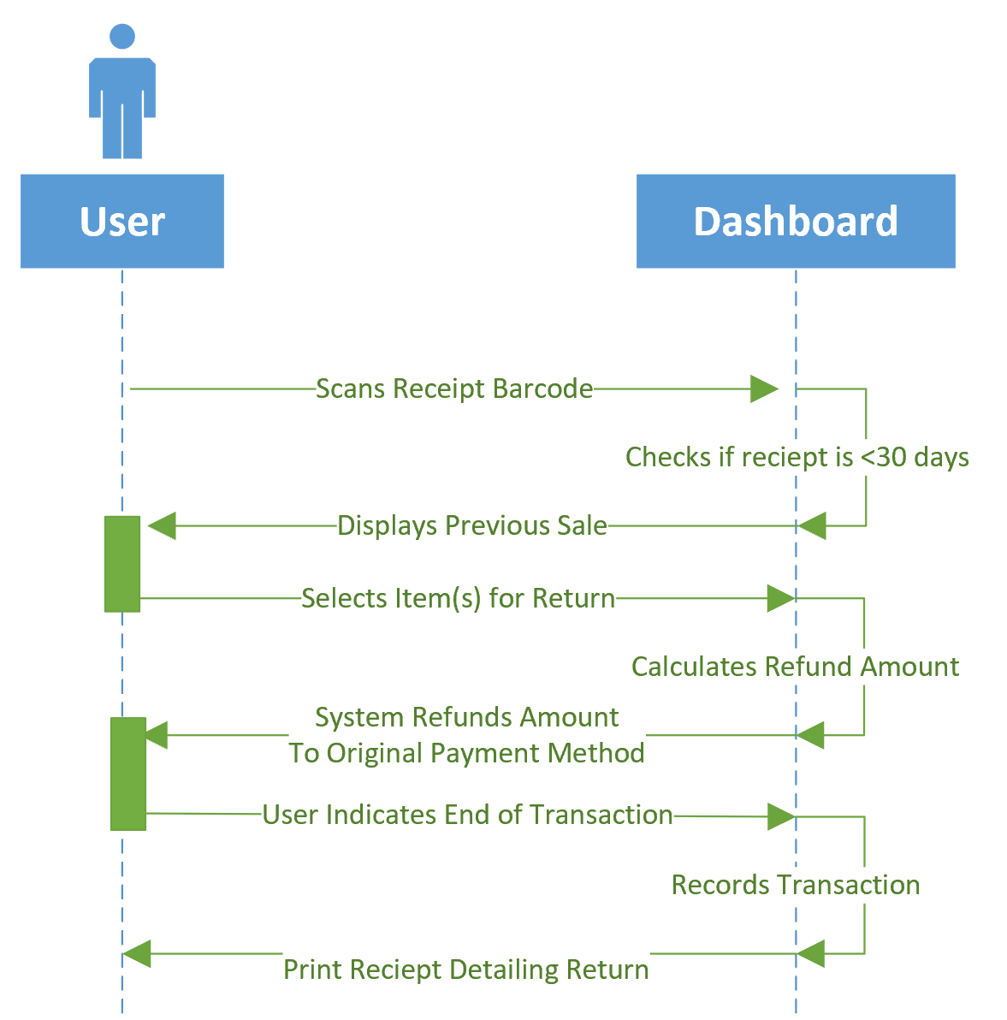

### 11. Use Cases Diagram:

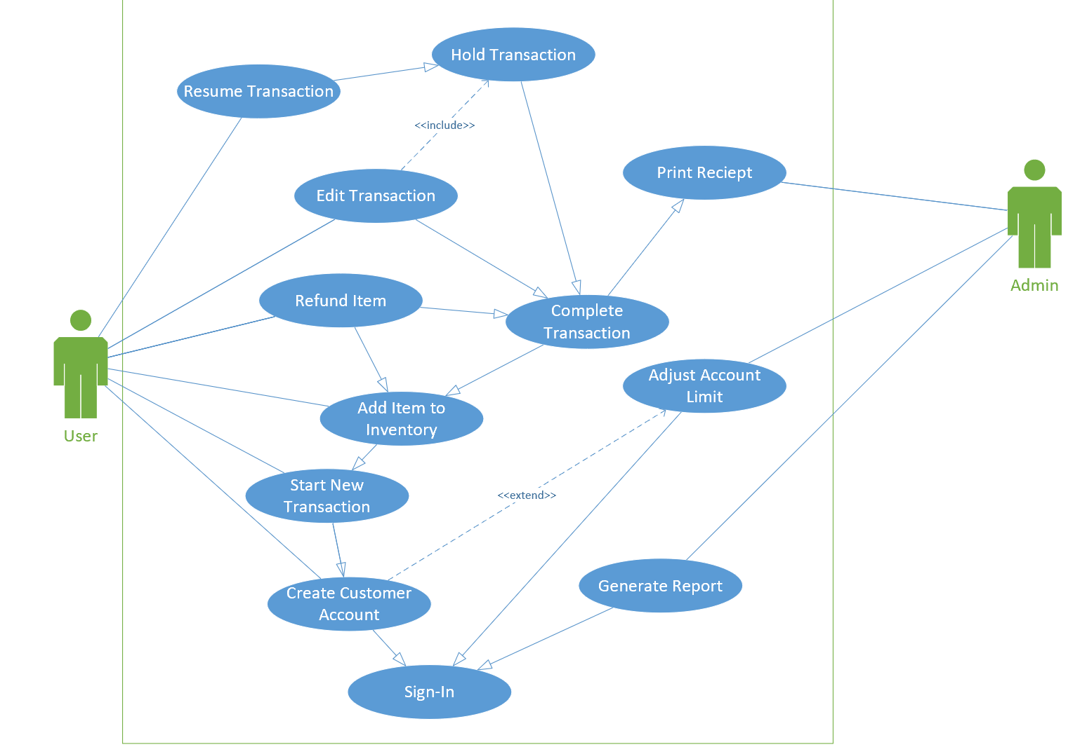

### 12. Activity Diagrams

#### 12.1 Complete transaction

#### 12.2 Hold transaction

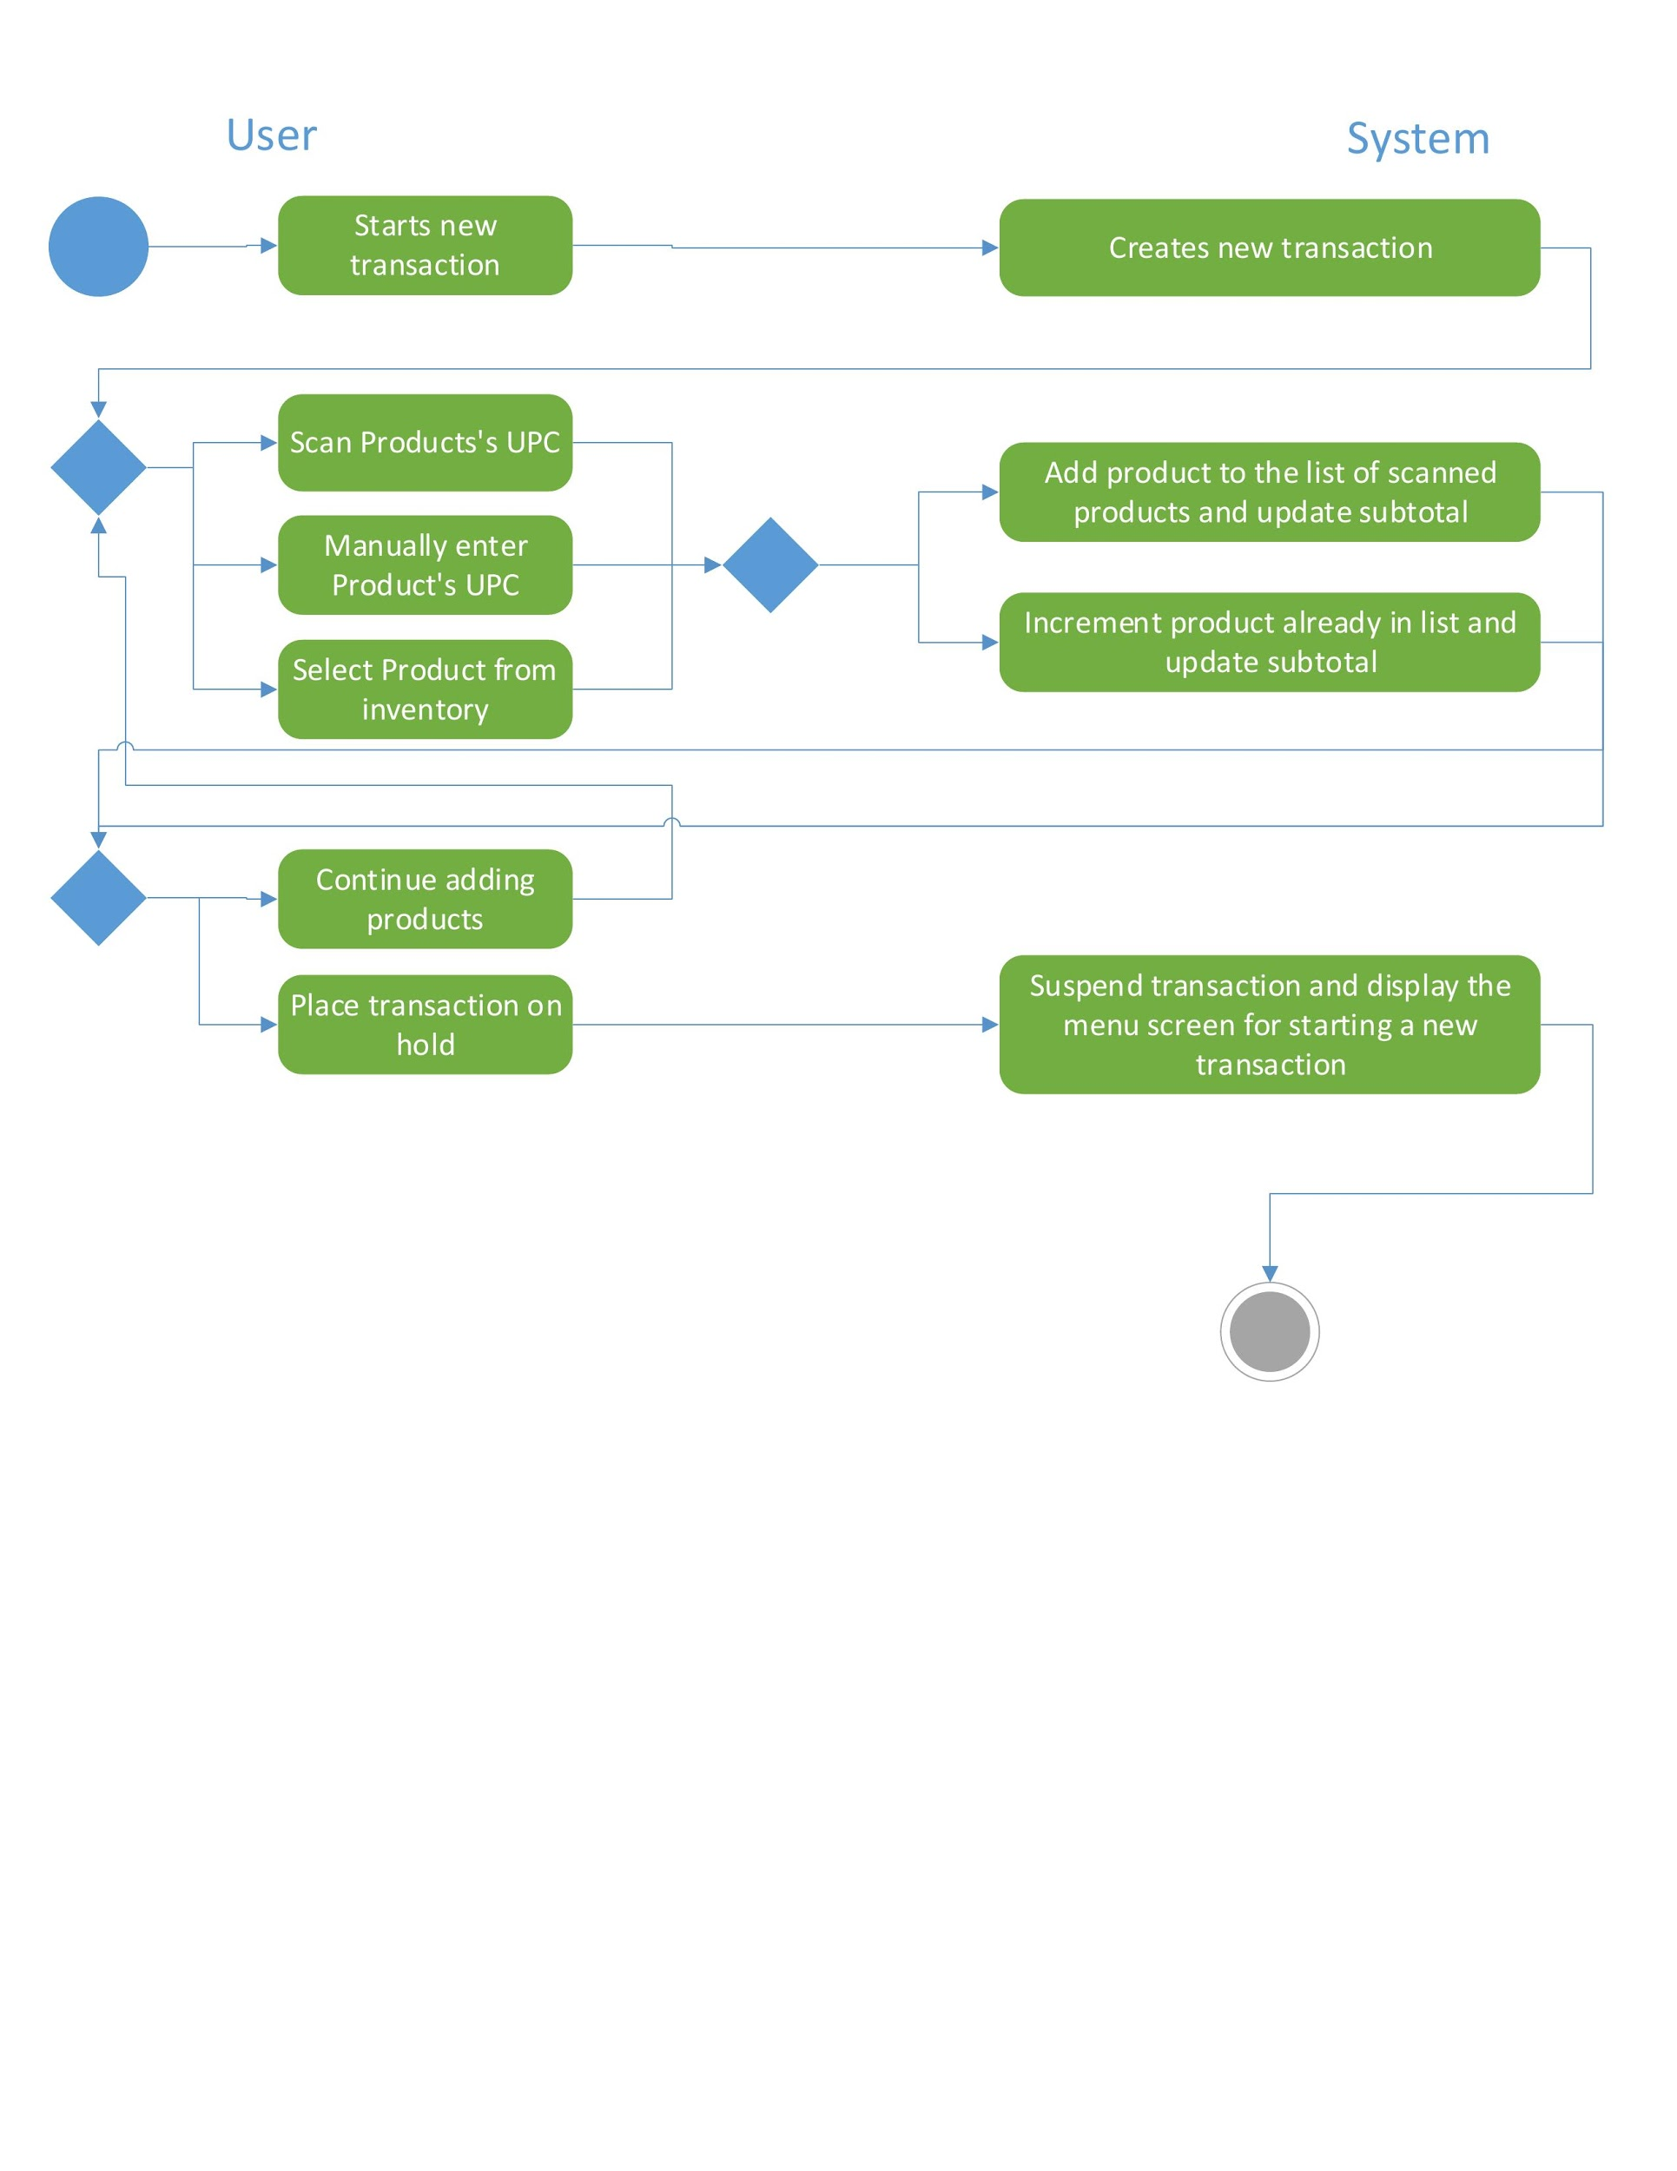

#### 12.3 Refund item

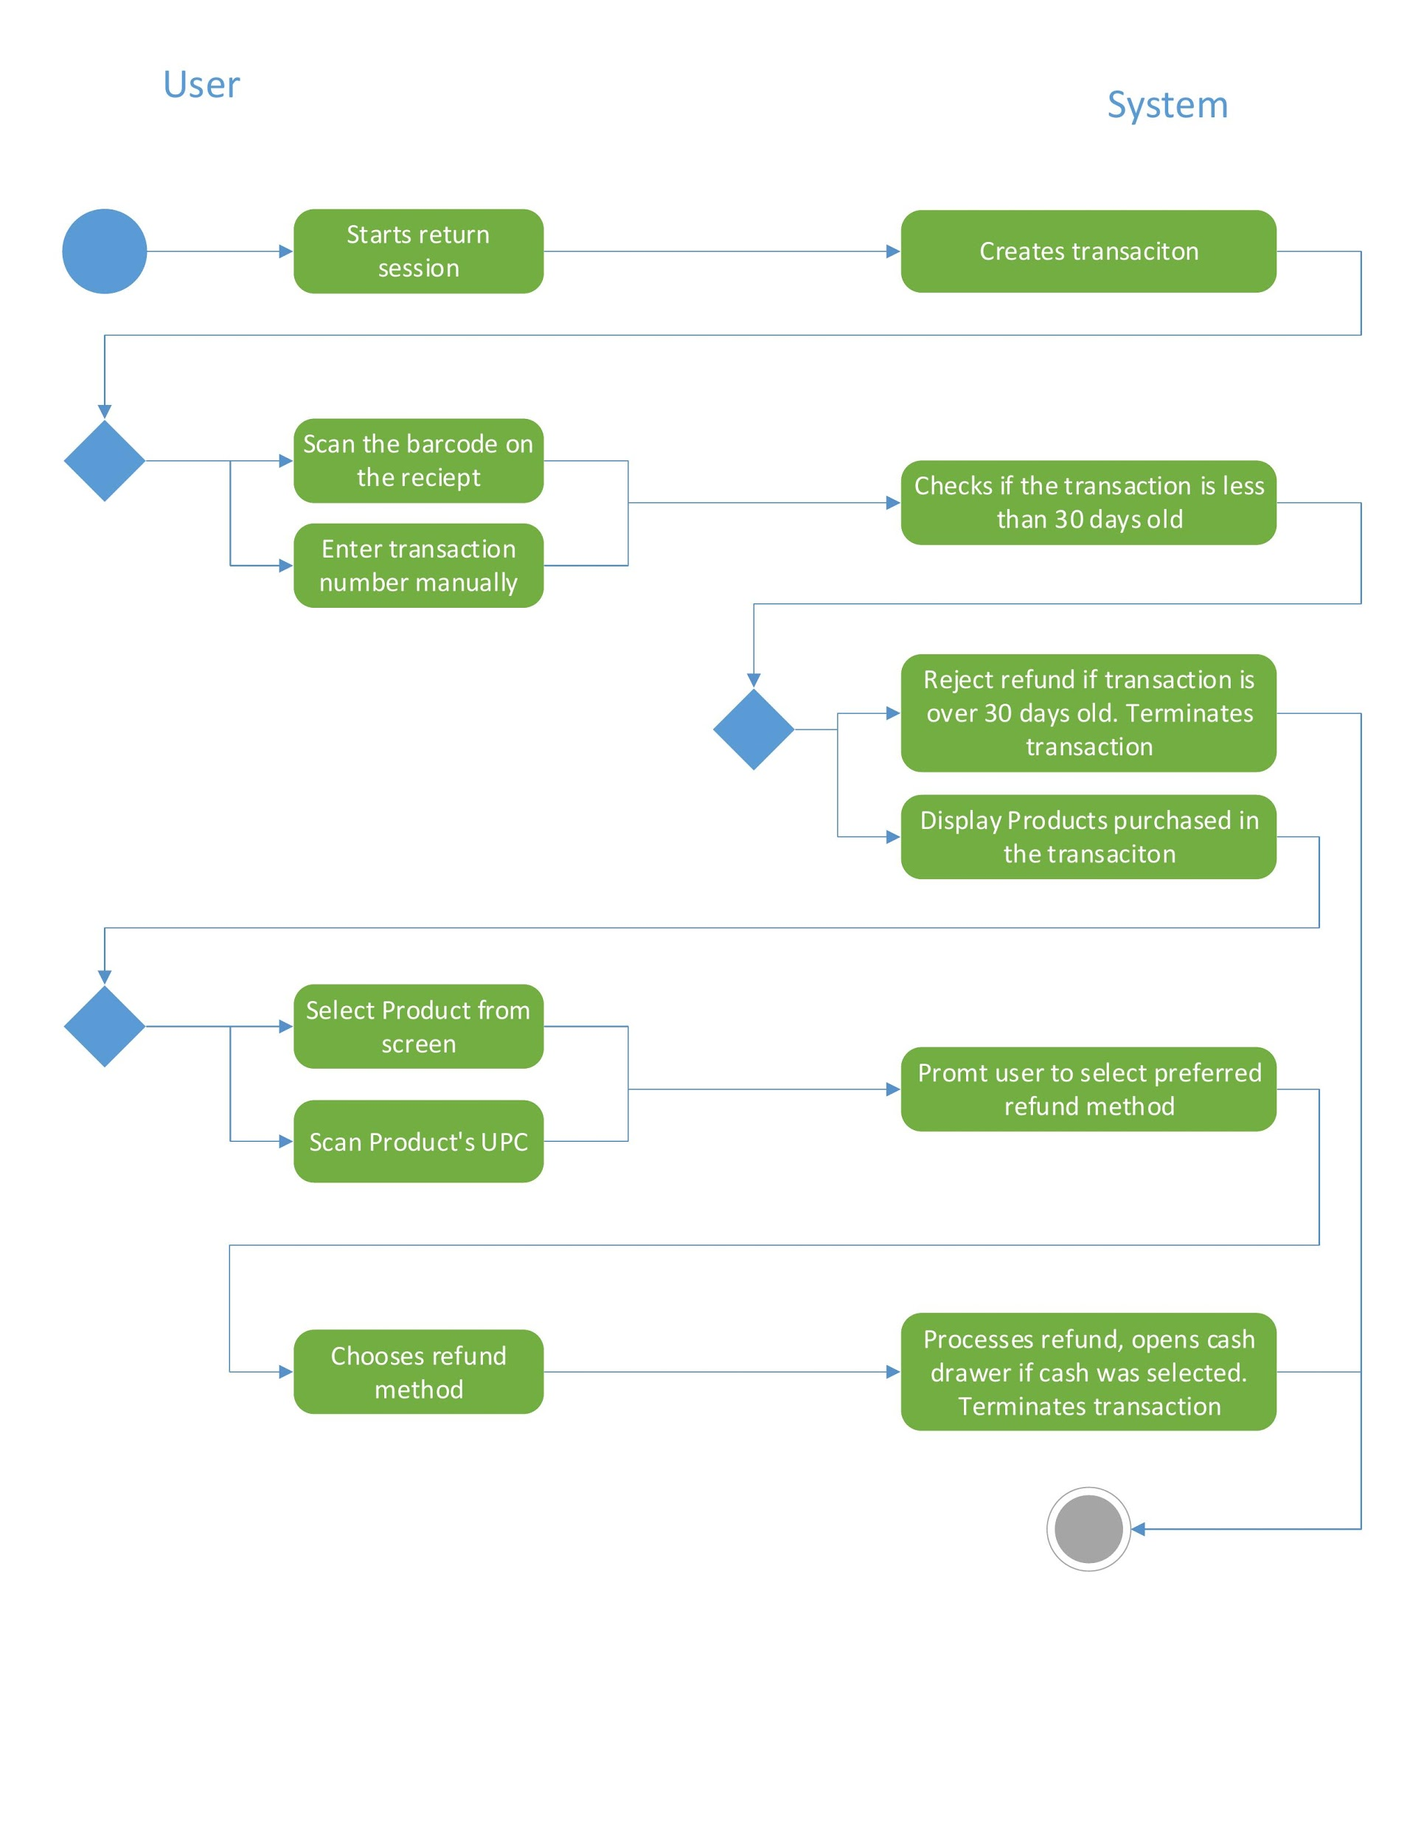

### 13. Class Diagram